E-FARMING

Sub: “Yantrik Krishi”

Team:

Sargam Badyal 10bce0385

Sadhana Muthu Kumar 10bce0100

Aditi Mahajan 10bce0003

**INDEX**

|  |  |  |
| --- | --- | --- |
| Srno | Topic | Page No |
| 1 | Introduction |  |
| 1.1 | Problem statement |  |
| 1.2 | Aim |  |
| 1.3 | Objective |  |
| 1.4 | Process Model |  |
| 1.5 | Scheduling Diagrams |  |
| 1.5.1 | Work Break down structure |  |
| 1.5.2 | Gantt chart |  |
| 1.5.3 | Pert Chart |  |
| 1.6 | Methodology |  |
| 1.7 | Scope |  |
| 1.8 | Abbreviations |  |
| 1.9 | Software requirements |  |
| 1.9.1 | Tools used |  |
| 1.9.2 | Technologies used |  |
| 1.9.3 | Product Perspective |  |
| 1.9.4 | Software Interface |  |
| 1.10 | Hardware Requirements |  |
| 1.12 | Functional Requirements |  |
| 1.13 | Non functional requirements |  |
| 2 | UML diagrams |  |
| 2.1 | Use case diagram |  |
| 2.1.1 | Use case tables |  |
| 2.2 | Sequence Diagram |  |
| 2.3 | Class Diagram |  |
| 2.4 | ER diagram |  |

1. **Introduction**

E-farming is an emerging field focused on the enhancement of agricultural and rural development through improved information and communication processes. It involves the conceptualization, design, development, evaluation and application of innovative ways to use information and communication technologies (ICTs) in the rural domain, with a primary focus on agriculture.

**1.1 Problem statement:**

Most of the farmers in India are still not aware about the technological advancements in farming thus are not able to fully avail the benefits. Moreover they also remain poor because of lack of information to various improvement plans of the government. Farmers are often deceived and made to sell their crops at cheaper rates. But his forum will help the farmers by keeping then aware of latest happenings in their field and help then progress more.

**1.2 Aim:**

Building a realistic technology that helps the farmers to be aware about the modern techniques and equipments for operation which will make their farming methods efficient.

**1.3 Objective:**

1. Enhance sustainable agricultural development
2. Bring the farmers close to the technology
3. Keep the farmers up to date with the latest advancements in the field of farming
4. Make a unified portal for farmers to buy high yield variety of seeds, manure and equipment at genuine rates.
5. Help the farmers solve the problems faced during the cultivation, irrigation, development and harvesting stages of the crop.
6. Train the farmers to use the website using a basic tutorial
7. Information spread in native language to improve understanding
8. One portal for marketing the products at the prize they want with active updating
9. Provide the security to crops by providing the certification and insurance to crops which they can apply for from the site itself.
10. Most importantly, the farmers can also upload the pictures of the crops which will be analyzed by our experts and the response will be send through SMS/ email.

**1.4 Process model:**

**RAD Process model:**

Rapid application development is a software development methodology, which involves iterative development and the construction of prototypes. It is a merger of various structured techniques, especially the data driven Information Engineering with prototyping techniques to accelerate software systems development

rad.JPG

**Justification:**

1. N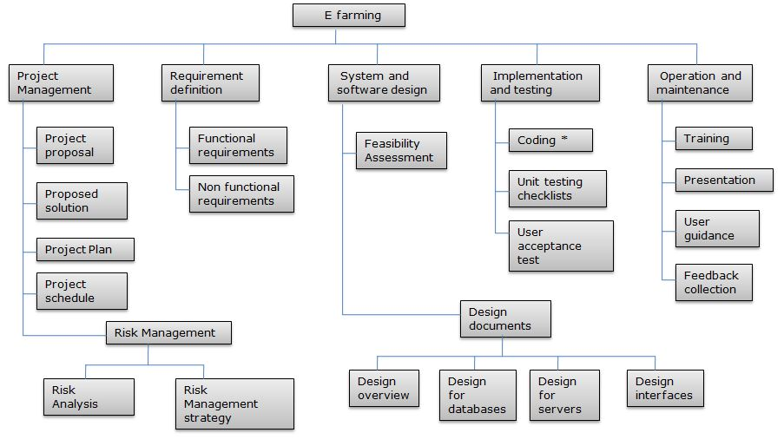o extensive pre-planning
2. Software is written much faster, and is easier to change requirements.
3. Can work in collaboration with the user(self) which increases the chances of easy approval of project
4. Software reuse is possible
5. Small team structure
6. Flexible and adaptable to change
7. Prototyping helps the users to see if the requirements are met.
8. It has short development cycles thus instant results
9. Overall reduction in project risk
10. Pareto's 80 - 20 Rule usually results in reducing the costs to create a custom system.
11. Relatively newer model and good to analyze its usefulness.

**1.5.1 Work breakdown structure:**

**1.5.2 Gant chart:**

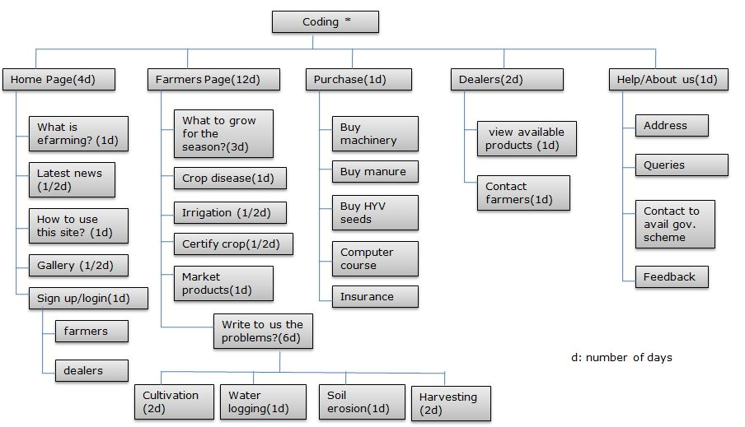

**1.5.3 Pert Chart**

**1.6 Methodology:**

We are using RAD model for the development of our project.

**Requiremnet planning:** Planning and anaysis of the system is done through different phases of the system development life cycle(SDLC). Users,managers and staff agrees on needs,project scope,constraints and system requirements.

**User design:** user design is a continuos process that allows the users to understand,modify and eventually approve a working model of the system that meets their requirements.

**Construction:** focus on program and application development task similar to the SDLC.Its tasks are programming and application development,coding,unit integration and system testing.

**Cutover:** Its tasks are data conversion,full scale testing,system changeover,user training.

**Purpose:**

E farming: project “ yantrik Krishi” will help the farmers to have a unified portal yo catter to their farming requiremnts in all ways.

The farmers living in remote areas can get updated information about new methods and techniques in no time. In this site where all the information about agriculture comes handy also problems are easily solved using our problem addressal portal.It helps the farmer to practice farming in the most advanced and haselfree way.

**1.7 Scope:**

There are four main stake holders for “Yantrik Krishi”

1. Farmers
2. Experts
3. Admin
4. Wholesale

* All the users have their own profiles.
* Farmers can get information from the site reguarding what crops should they grow depending upon they season and topology.
* Farmers can ask queries to the experts about crop diseases, water logging, soil erosion, organic manure, fertilization, irrigation etc.
* Farmers can buy advanced machinery, seeds, fertilizers and insurance for their crops.
* Admins approve the users(farmers and wholesaler) checking their ID’s and verifying the accouts and also approve the scale of the farmer.They can add/delete the users and grant permissions to users, experts and wholesaler.
* Experts can maintain their accounts and answer the queries of the farmers.
* Wholesale can buy the products from the farmers.

**1.8 Definitions, Acronyms and Abbreviations**

Admin: Administrator

WAMP: Windows, Apache, MySQL, PHP/Perl/Python

MYSQL: My Structured Query Language

RDMS: [Relational Database Management System](http://en.wikipedia.org/wiki/Relational_database_management_system)

YK: Yantrik Krishi

JS: Java script

PHP: PHP: Hypertext Preprocessor

HTML: Hyper Text markup language

HTTP: HyperText Transfer Protocol

HTTPS: HyperText Transfer Protocol Secure

CSS: Cascading style sheets

AJAX:  Asynchronous JavaScript and XML

**1.9 Software requirements:**

**1.9.1 Tools Used:**

**Application Architecture: PHP, HTML, Javascript, ajax**

**PHP:** PHP is an open source [server-side scripting](http://en.wikipedia.org/wiki/Server-side_scripting) language designed for [Web development](http://en.wikipedia.org/wiki/Web_development) to produce [dynamic Web pages](http://en.wikipedia.org/wiki/Dynamic_Web_page). It is one of the first developed server-side scripting languages to be embedded into an [HTML](http://en.wikipedia.org/wiki/HTML) source document rather than calling an external file to process data. The code is [interpreted](http://en.wikipedia.org/wiki/Interpreter_(computing)) by a Web server with a PHP processor module which generates the resulting Web page. It has also evolved to include a [command-line interface](http://en.wikipedia.org/wiki/Command-line_interface) capability and can be used in [standalone](http://en.wikipedia.org/wiki/Computer_software) [graphical applications](http://en.wikipedia.org/wiki/Graphical_user_interface).[[2]](http://en.wikipedia.org/wiki/PHP" \l "cite_note-2) PHP can be deployed on most Web servers and also as a standalone [shell](http://en.wikipedia.org/wiki/Shell_(computing)) on almost every [operating system](http://en.wikipedia.org/wiki/Operating_system) and [platform](http://en.wikipedia.org/wiki/Computing_platform), free of charge.

**HTML:** It is the main [markup language](http://en.wikipedia.org/wiki/Markup_language) for displaying [web pages](http://en.wikipedia.org/wiki/Web_page) and other information that can be displayed in a [web browser](http://en.wikipedia.org/wiki/Web_browser). HTML is written in the form of [HTML elements](http://en.wikipedia.org/wiki/HTML_element) consisting of *tags* enclosed in [angle brackets](http://en.wikipedia.org/wiki/Angle_brackets)(like <html>), within the web page content. The purpose of a [web browser](http://en.wikipedia.org/wiki/Web_browser) is to read HTML documents and compose them into visible or audible web pages. The browser does not display the HTML tags, but uses the tags to interpret the content of the page.HTML elements form the building blocks of all [websites](http://en.wikipedia.org/wiki/Website).

**Javasript:** JavaScript (JS) is an open source [client-side](http://en.wikipedia.org/wiki/Client-side_scripting) [scripting language](http://en.wikipedia.org/wiki/Scripting_language) commonly implemented as part of a [web browser](http://en.wikipedia.org/wiki/Web_browser) in order to create enhanced [user interfaces](http://en.wikipedia.org/wiki/User_interface) and dynamic [websites](http://en.wikipedia.org/wiki/Website).JavaScript is [prototype-based](http://en.wikipedia.org/wiki/Prototype-based) scripting language that is [dynamic](http://en.wikipedia.org/wiki/Dynamic_language), [weakly typed](http://en.wikipedia.org/wiki/Weak_typing) and has [first-class functions](http://en.wikipedia.org/wiki/First-class_functions). It uses [syntax](http://en.wikipedia.org/wiki/JavaScript_syntax) influenced by the language [C](http://en.wikipedia.org/wiki/C_(programming_language)).

**Ajax:** It is a group of interrelated [web development](http://en.wikipedia.org/wiki/Web_development) techniques used on the [client-side](http://en.wikipedia.org/wiki/Client-side) to create asynchronous [web applications](http://en.wikipedia.org/wiki/Web_application). With Ajax, web applications can send data to, and retrieve data from, a [server](http://en.wikipedia.org/wiki/Web_server) asynchronously (in the background) without interfering with the display and behavior of the existing page. Data can be retrieved using the [XMLHttpRequest](http://en.wikipedia.org/wiki/XMLHttpRequest) [object](http://en.wikipedia.org/wiki/Object_(computer_science)). Despite the name, the use of XML is not required ([JSON](http://en.wikipedia.org/wiki/JSON) is often used instead), and the requests do not need to be [asynchronous](http://en.wikipedia.org/wiki/Asynchronous_I/O).

**Application development tool: Notepad++**

**Notepad++:** Notepad++ is a [text editor](http://en.wikipedia.org/wiki/Text_editor) and [source code editor](http://en.wikipedia.org/wiki/Source_code_editor) for [Windows](http://en.wikipedia.org/wiki/Microsoft_Windows). It aims to be a lightweight and robust editor for a variety of programming and scripting languages. One advantage of Notepad++ over the built-in Windows text editor [Notepad](http://en.wikipedia.org/wiki/Notepad_(Windows)), is that Notepad++ supports [tabbed editing](http://en.wikipedia.org/wiki/Tab_(GUI)), which allows working with multiple open files.

**Web server: WAMP 2.0**

**WAMP:** WAMPs are packages of independently created programs installed on computers that use a [Microsoft Windows](http://en.wikipedia.org/wiki/Microsoft_Windows) operating system.WAMP is an acronym formed from the initials of the operating system Microsoft Windows and the principal components of the package:[Apache](http://en.wikipedia.org/wiki/Apache_HTTP_Server), [MySQL](http://en.wikipedia.org/wiki/MySQL) and one of [PHP](http://en.wikipedia.org/wiki/PHP), [Perl](http://en.wikipedia.org/wiki/Perl) or [Python](http://en.wikipedia.org/wiki/Python_(programming_language)). Apache is a [web server](http://en.wikipedia.org/wiki/Web_server).

**Design tool: CSS**

**CSS:** It is a [style sheet language](http://en.wikipedia.org/wiki/Style_sheet_language) used for describing the[presentation semantics](http://en.wikipedia.org/wiki/Presentation_semantics) (the look and formatting) of a document written in a [markup language](http://en.wikipedia.org/wiki/Markup_language). Its most common application is to style [web pages](http://en.wikipedia.org/wiki/Web_page) written in [HTML](http://en.wikipedia.org/wiki/HTML) and [XHTML](http://en.wikipedia.org/wiki/XHTML), but the language can also be applied to any kind of [XML](http://en.wikipedia.org/wiki/XML) document, including [plain XML](http://en.wikipedia.org/wiki/Plain_Old_XML), [SVG](http://en.wikipedia.org/wiki/Scalable_Vector_Graphics) and[XUL](http://en.wikipedia.org/wiki/XUL).

**Database platform: PHP Myadmin**

**PHP Myadmin:** phpMyAdmin is a [free and open source](http://en.wikipedia.org/wiki/Free_and_open_source) tool written in [PHP](http://en.wikipedia.org/wiki/PHP) intended to handle the administration of [MySQL](http://en.wikipedia.org/wiki/MySQL) with the use of a [Web browser](http://en.wikipedia.org/wiki/Web_browser). It can perform various tasks such as creating, modifying or deleting [databases](http://en.wikipedia.org/wiki/Database), [tables](http://en.wikipedia.org/wiki/Table_(database)), [fields](http://en.wikipedia.org/wiki/Field_(computer_science)) or [rows](http://en.wikipedia.org/wiki/Row_(database)); executing [SQL](http://en.wikipedia.org/wiki/SQL) statements; or managing users and permissions.

**Database Management System: Mysql**

**MySQL:** It is the world's most usedopen source RDBMS as of 2008 that runs as a server providing multi-user access to a number of databases. MySQL is a popular choice of database for use in web applications.

**References:**

* [**http://en.wikipedia.org/wiki/**](http://en.wikipedia.org/wiki/)
* [**http://fullforms.com/**](http://fullforms.com/)
* **http://www.wampserver.com/en/**

**1.9.2 Technologies to be used:**

* RDBMS: For the database management system
* Wamp 2.0: Web development proxy server
* Filezilla: hosting the website
* 5gbfree.com the online free server

**1.9.3 Product Perspective:**

Web Application Sphere

Database management system + database

Web host page management engine

mysql

HTTP

PHP mailer Site

Gov. Agencies/ insurance/products

External site

**1.9.4 Software Interface:**

**Client Server:**

Web browsers(preferably Google Chrome), operating system (any)

**Web server:**

Host server(any),WAMP, operating system(any)

**Database server:**

Mysql, phpmyadmin, operating system (any)

**Development end:**

Php,javascript,html,mysql,ajax,css,OS(windows),notepad++(editor),netbeans(optional),css inliner tool(optional)

* 1. **Hardware requirements:**

|  |  |  |  |  |
| --- | --- | --- | --- | --- |
|  | Processor | RAM | Disk Space | Additional |
| *Web Browser (Internet Explorer 7+, Firefox 3.5+, Google Chrome 3+, Opera 9+, Safari 3+)* | ***A 800-MHz Intel Pentium III processor or equivalent*** | ***512 MB of RAM (1GB recommended)*** | **100MB** | ***1024 x 768 resolution color display or better (1280 x 800 or 1280 x 1024 recommended)*** |
| WAMP | ***3-GHz Intel Processor or equivalent*** | ***3GB of RAM (4 GB recommended)*** | ***60 GB of available disk space*** | *PHP Server (version 5.3)*  *MySQL Server (version 5.x)* |
| Host server | ***A 800-MHz Intel Pentium III processor or equivalent*** | ***20480MB*** | ***5120MB*** | *File manager, disk space usage, Mysql databases* |

**1.11 Functional Requirements:**

1. **Login requirements:**

Input**:** username and password

Output: Authenticated page to access the personalized view of the site and access the functions they perform.

Preconditions: user should have a pre registered account verified by our two way access checking system, password constraints (special character etc)

Post conditions: users can change specific information only

The logins will provide the users ie the farmers, experts and the dealers with a variety of services like change password, forgot password, change details, post function specific queries. The portals will appear different for each user in the scene depending on the functions they perform. The password will be stored with the help of encryption key and all the other data will also be secured with a key.

1. **What crop to grow?**

Input: season, soil type, topology, temperature range, budget etc

Output: list of crops to grow

Preconditions: registers farmer, farmer has knowledge about conditions

Post conditions: NA

Farmers will get knowledge about the crops to grow as the system will analyze the various physical factors and market trends and suggest crops which will benefit the farmer most. The farmer can choose from the list or choose his own crop and register his crop with us for further support.

1. **Problems during farming:**

Input: problem, picture, detailed remarks

Output: Reply from the expert through SMS/email

Precondition: registered and verified email and phone number

Post condition: No surety while network is out.

The problems can either be chosen from the list already provided and found a solution for otherwise specific problems will be addressed to the experts for their opinion. The problems will be answers within 24 hours of the query postage.

1. **Dealing crops:**

Input: crop type, crop quality, crop certification, crop quantity, price, place

Output: Deal number, the details of the interested buyer

Precondition: certification of crop, registers user

Postcondition: actual transaction happens offline

The farmers post to market their certified crops to the buyers and the transaction happen outside the supervision of the website. It’s the duty of the buyer and the seller to take care of the transaction of crop and money. Only certification of crop, dealer and the farmer is done by the website. The contact happens in the office.

1. **Feedback**

Input: complaints and suggestions

Output: replies

The feedback form will be available at the website and all suggestions are welcome. Replies are sent as soon as possible.

1. **Contact with government and other support agencies:**

Input: details of farmers, dealers etc

Output: Authentication certification

Precondition: Agencies legitimately known to the admin

Post condition: Site holds no responsibility for contact with outside agencies

The farmers, dealers will be verified. The government agencies also give inputs to the site regarding its development plans. Also commercial agencies market their products with authentication.

1. **Buy products:**

Input: details of farmer, product details, billing details

Output: Shipment of product/selling of product

Precondition: secure channel for payment, link with the banking site

Post condition: Admins can only add/delete/modify products

The farmers can buys various products like crops, manure, weedicites etc and machines like thresher, tractor etc on our site, the products will be added by the admins.

1. **Reset password/ forgot password:**

Input: username, verified email account/old password

Output: Password reset mail

Precondition: Verified user, password constraints (special character etc)

The users except the admins can use forgot password, reset password can be used by all. This will help to recover account fast and manage the unwanted and unverified accounts. This also helps in maintaining the security. It is advised to change the password every 40 days.

**1.12 Non-functional Requirements:**

1. **Ethical requirements:**

* Security procedure to keep the information of all users intact.
* We need algorithm to make sure all the users registering actually exist.
* We need safety mechanism to ensure the process is not dubious.

1. **Availability:**  
    The availibility of the system is 24X7.
2. **Prerequisite:**  
    Basic knowledge of english is required to use the website. There is a language option that can be selected to ease out the complex information.
3. **Computer course:**  
   Classes for the use of computers are required to use the website, provision for which is made as a part of the of the initiative. User manuals will be provided.
4. **Accuracy:**  
   Accuracy of the system is high.
5. **Mean time between failure:**  
   Mean time between failure is very high as the system is not prone to any catastrophe.
6. **Low mean time for repair:**  
   Mean time for repair is very low as any bugs can be fixed in a definite and small period of time.
7. **Low response time:**  
   Response time is low as the system is designed to react ay higher speeds by using minimum time and space complexity.
8. **Optimum resource utilization:**  
   Resource utilization is optimum in the system.
9. **Ensure delivery and payment:**  
   All money transactions will not be online, as we want to ensure the delivery of product and payment both.
10. **Support from government:**  
    We need support from government for providing insurance and certification to the crops.
11. **University sponsorship:**  
    We need to call for sponsors from various biotech universities to provide us with HYV seeds and new technologies to make them available to farmers and dealers.
12. **Accurate information:**  
    All the information provided by the users regarding the cultivation area should be accurate for the proper results.
13. **Reliable:**  
    The system itself is highly reliable.
14. **UML diagrams:**

**2.1 Use case diagram:**



**Use case for the Farmers:**

|  |  |
| --- | --- |
| Register | Create a profile on the website |
| Login | Enter into your profile |
| Home | Get all updates on the home page |
| Search | Farmers can search for potential buyers |
| Take classes | Learn the baisc use of internet |
| Update profile | Update the information about crops to be sold |
| Insurance | File for crop insurance |
| Post queries | Enquire about any problems from the experts |
| Crop certification | Get your crops certified for quality assurance |
| Report complaint | Report complaint against any trouble in communication or transaction trust with the dealer |
| Logout | For signing out of the profile |

**Use case for the dealers:**

|  |  |
| --- | --- |
| Register | Create a profile on the website |
| Login | Enter into your profile |
| Update profile | Dealer can update their choices of crops and area |
| Home | Get allthe updates on the home page |
| Search | Dealer can search for potential crops to buy |
| Contact | Dealers can contact farmers for transactions |
| Report complaint | Report complaint against any trouble in communication or transaction trust with the farmer |
| Feedback | Give feedback for the improvement of the process |
| Logout | For signing out of the profile |
| Help | To know about any functionality of the website |

**Use case for experts:**

|  |  |
| --- | --- |
| Register | Register to obtain an acccount in the website |
| Login | Login to the website with the username and password |
| Home | Check all the updates about the initiative |
| Select farmer | Experts can select farmers whose query they want to answer |
| Read details | View the details of the farmers area and climate of the place |
| Solution | Find a viable solution |
| Reply | Reply to the query with the solution |
| Report | Generate reports to keep record of the situations |
| Logout | Sign out from their account |

**Use case for admins:**

|  |  |
| --- | --- |
| Login | Login into the website with username and password |
| Recieve feedback | Recieve feedback from farmers and dealers to improve the process |
| Respond to complaints | Try to improvise and remove complaints is any |
| Database management | To manage databases for farmer records and dealer records as well queries |
| Reports | To keep recoeds or a log of all the transactons to roll back in case of failure |
| Delete users | If any user has been inactive for a prolonged period, remove them. |

**2.2 Class diagram**





Sequence Diagram for Signup

Sequence Diagram for Buy crop





Sequence Diagram for query the expert

**2.4 ER Diagram**

